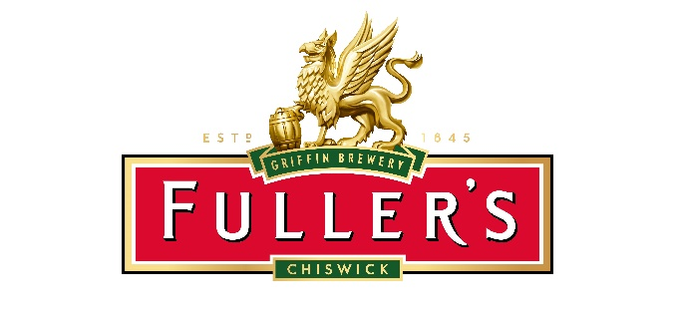
24 July 2018
FULLER, SMITH & TURNER P.L.C.
AGM Trading Statement
16 weeks to 21 July 2018

Fuller, Smith & Turner P.L.C. (“Fuller’s” or “the Company”), the London brewer and premium pub company, today makes the following trading statement for the 16 weeks from 1 April to 21 July 2018 (“the period”), in advance of the Company's Annual General Meeting to be held today [24 July 2018] at 11am, in The Hock Cellar, Griffin Brewery, Chiswick, London W4 2QB.
The Company has made a good start to the new financial year with like for like sales in our Managed Pubs and Hotels rising 4.0%, particularly pleasing against a strong comparative of 6.6% for the same period in the prior year. Like for like profits in our Tenanted Inns were up 4% and total beer and cider volumes in The Fuller’s Beer Company were flat.

Chief Executive Simon Emeny said: “Our core business has performed well, with the prolonged summer weather benefiting our pubs with outside space and our latest acquisitions are bedding in well and performing to plan. We have a number of exciting schemes lined up for the coming year, including refurbishments of the four We Are Bar sites acquired in June and the opening of two new station sites at Euston and Liverpool Street. Recent investment in our Destination Chiswick initiative has been well received and included the opening of our new brewery shop and pilot plant.

“Although we have undoubtedly benefited from the feel-good factor of England’s World Cup performance and good summer weather, it is important to remember that the underlying economic and political situation, particularly the UK’s position with regards to Europe, creates uncertainty and it is difficult to predict the nature of any potential impact on the sector.

“However, Fuller’s is a well-balanced company that is founded on iconic pubs and a premium portfolio of outstanding brands, underpinned by an excellent team of people. We have exciting plans in place to keep us relevant and interesting to today’s consumer and we face the coming year in a strong position and with a positive outlook.”

The next report will be on 23 November 2018, when the Company issues its half year results for the 26 weeks to 29 September 2018.

- Ends –

For further information, please contact:
Fuller, Smith & Turner P.L.C.
Simon Emeny, Chief Executive (press) 020 8996 2135
James Douglas, Finance Director (analysts) 020 8996 2000
Georgina Wald, Corporate Comms Manager 020 8996 2198/07831 299801

Instinctif Partners
Justine Warren 020 7457 2020

Notes to Editors:

Fuller, Smith and Turner P.L.C. is an independent traditional family brewer founded in 1845 and is based at the historic Griffin Brewery in Chiswick, London, where brewing has taken place continuously since 1654. As of today [24 July 2018], the Company runs 179 Tenanted pubs and 209 Managed Pubs and Hotels, with a focus on delicious fresh, home-cooked food, outstanding cask and craft ale, great wine and exceptional service. The Company also has 781 boutique bedrooms in its Managed estate. The Fuller’s pub estate stretches from Brighton to Birmingham and from Bristol to the Greenwich Peninsula, including 174 locations within the M25. In June 2018 Fuller’s acquired Bel & The Dragon, comprising six stunning country inns (included in the pub numbers above), and the Company also owns The Stable, a craft cider and gourmet pizza restaurant business, which has 17 sites in England and Wales.

The Fuller’s Beer Company brews a portfolio of premium beers including London Pride, Frontier Premium London Lager and a variety of cask and craft keg beers supported by a changing seasonal range. The Company owns Cornish Orchards – a craft cider maker producing a range of award-winning ciders and premium soft drinks – and Nectar Imports, a wholesale drinks business. In February 2018, Fuller’s also acquired Dark Star Brewing, a craft cask brewer based in Sussex.

